School of Informatics & IT
Diploma in Applied Artificial Intelligence
Machine Learning for Developers (CAI2C08)
AY2026/2027 April Semester
Program Codes
SUBMITTED BY:
(Name of student) | (Admin number)
Evan Lim | 2501678C

Declaration of Originality
I am the originator of this work, and I have appropriately acknowledged all other original sources used as my reference for this work.
I understand that Plagiarism is the act of taking and using the whole or any part of another person’s work, including work generated by AI, and presenting it as my own.
I understand that Plagiarism is an academic offence
and if I am found to have committed or abetted the offence of plagiarism in relation to this submitted work, disciplinary action will be enforced.
(Name of student) | (Signature)
Evan Lim | 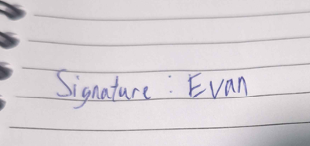

AY2026-27 APRIL SEMESTER
Declaration on the use of Generative AI tools for assignments
Include the links of your Generative AI conversations below:
Describe how you have used Generative AI tools such as ChatGPT or Dall.E-2 in your assignment.
Show snapshots of the conversations with the AI tool (i.e., the prompts you used and the response you get from the AI tool).
How to indicate the reference?
The content generated by AI tools is not retrievable except by the user who generated them, so they are considered non-recoverable sources. For non-recoverable sources:
- do not include in a reference list
- cite within the text as personal communications or correspondence
Based on APA 7th edition referencing format,
(Communicator, personal communication, Month Day, year)
E.g. (Paraphrase from OpenAI's ChatGPT AI language model, personal communication, March 8, 2023).

Important Note:
- Do not copy answers produced by the AI tool in totality as it is considered as plagiarism.
- Do not rely on any information produced by the AI tool blindly. You should always verify the answer with other sources. Do not assume that these answers provided by the AI tool are correct.
- To achieve quality outputs from the AI tool, you should provide good prompt that is clear and specific. Be precise and provide context. Avoid asking open-ended questions.

References / Citations

Source of dataset | https://archive.ics.uci.edu/dataset/45/heart+disease
GitHub link | https://github.com/Evan-Lim-123/mldp-heart-disease-model
Streamlit link | https://mldp-heart-disease-model.streamlit.app/

3 screenshots
(1) Before any option is selected
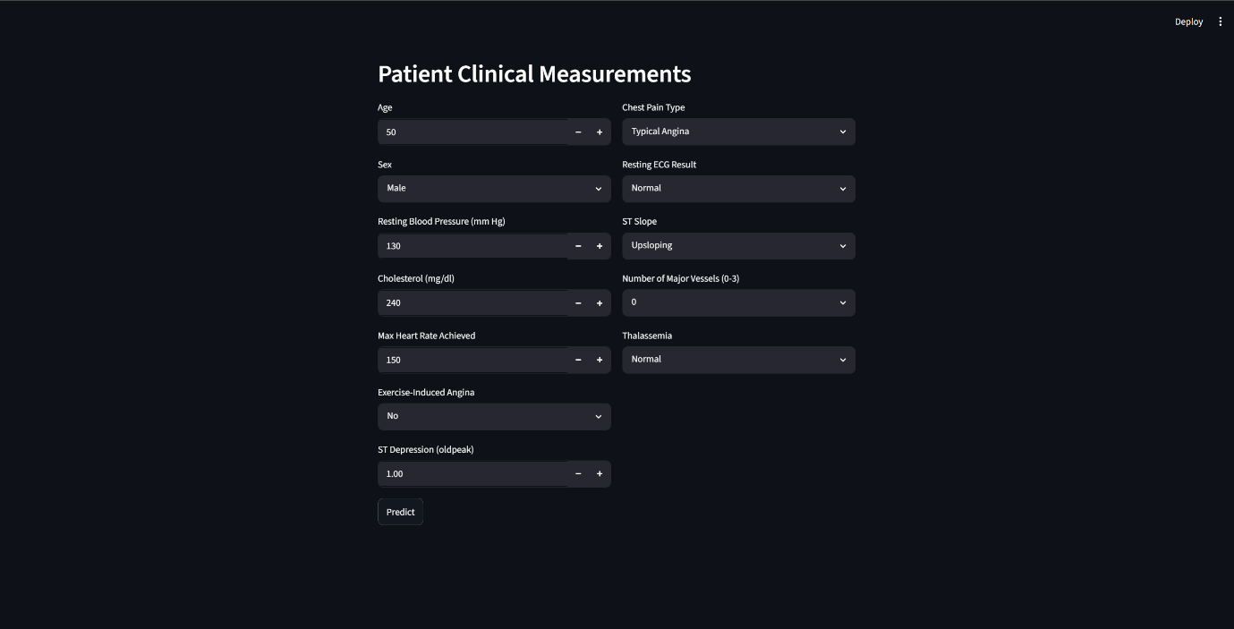
(2) After an option is selected (should show a prediction)
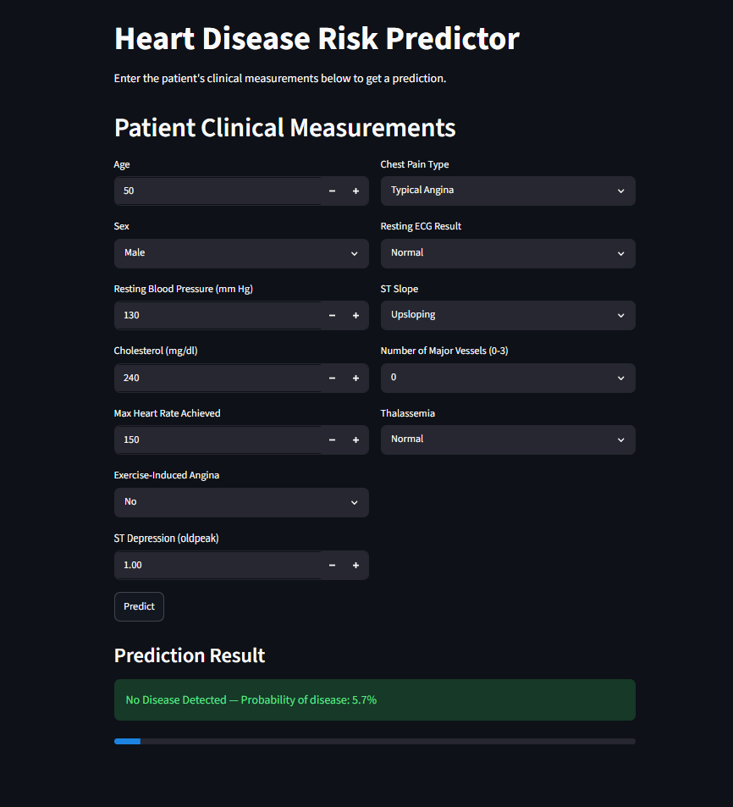
(3) After another option is selected (should show a change in value for the
prediction)
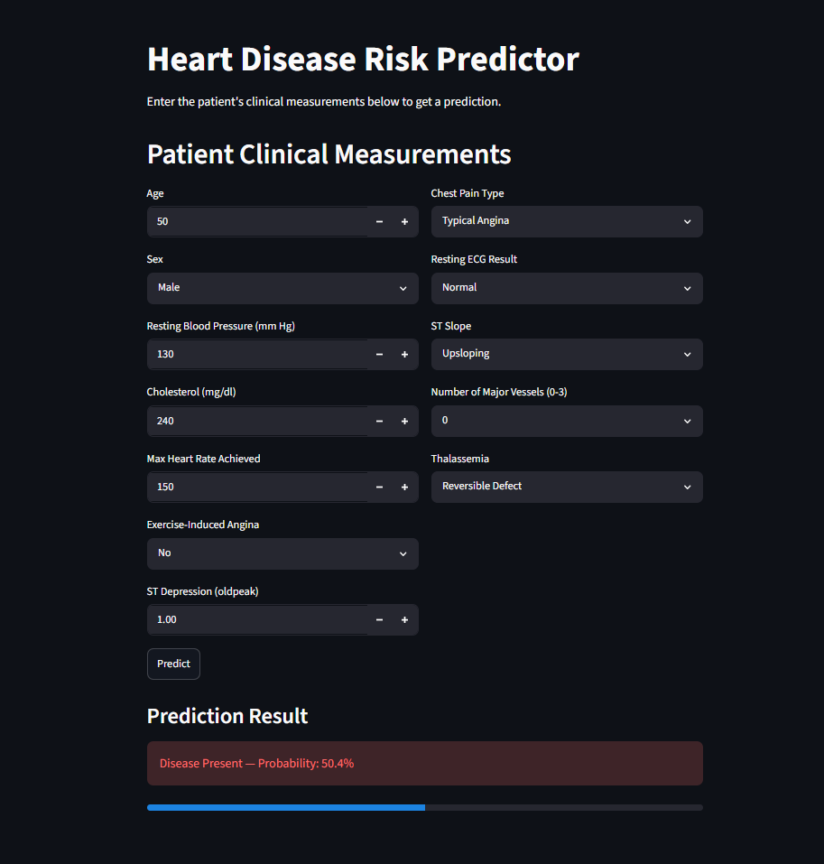
Screenshots of version control or development logs (if applicable)
